H.T No
Regulations:
A18

Sreenidhi Institute of Science and Technology
(An Autonomous Institution)
Code No:7D301 Date: 22-Jan-2025 (FN)

B.Tech II-Year I- Semester External Examination, Jan/Feb-2025 (Supplementary)
DISCRETE STRUCTURES AND GRAPH THEORY (ECM)

Time: 3 Hours Max.Marks:70

Note: a) No additional answer sheets will be provided.
b) All sub-parts of a question must be answered at one place only, otherwise it will not be valued.
c) Missing data can be assumed suitably.
Bloom's Cognitive Levels of Learning (BCLL)

Remember | L1 | Apply | L3 | Evaluate | L5
Understand | L2 | Analyze | L4 | Create | L6

Part - A Max.Marks:20

Answer all QUESTIONS.

 |  | BCLL | CO(s) | Marks
1 | Show that 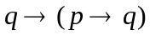 is a tautology. | L2 | CO1 | [2M]
2 | If 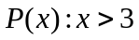 and the universe of discourse consists of all real numbers then write the truth values of i. 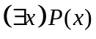 and ii. 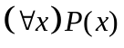. | L2 | CO2 | [2M]
3 | Differentiate Reflexive and Irreflexive relations with example. | L1 | CO3 | [2M]
4 | Find the coefficient of 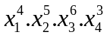 in the expansion of 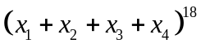 | L2 | CO4 | [2M]
5 | Solve 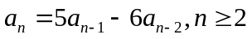. | L2 | CO5 | [2M]
6 | Differentiate matchinga and covering. | L1 | CO6 | [2M]
7 | List the rules of inference. | L1 | CO1 | [2M]
8 | How many different strings can be made from the letters of the word “SUCCESS” using all the letters? | L2 | CO3 | [2M]
9 | Write adjacency and incidence matrices of the following graph.  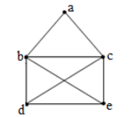 | L2 | CO5 | [2M]
10 | Define Lattice. | L1 | CO6 | [2M]

Part – B Max.Marks:50
ANSWER ANY FIVE QUESTIONS. EACH QUESTION CARRIES 10 MARKS.

 |  |  | BCLL | CO(s) | Marks
11. | a) | Rephrase the statement formula as principal conjunctive normal form. | L3 | CO1 | [5M]
 | b) | Make use of inference rules derive from the premises 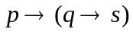, 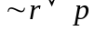 and q. | L3 | CO1 | [5M]
12. | a) | Define quantifier. Describe types of quantifiers with suitable examples. | L2 | CO2 | [5M]
 | b) | Verify the validity of the following argument:  “All men are mortal. Socrates is a man. Therefore, Socrates is mortal.” | L3 | CO2 | [5M]
13. | a) | Show that Congruence relation is an Equivalence relation. | L3 | CO3 | [5M]
 | b) | Prove that the fourth roots of unity forms a group under usual multiplication. | L3 | CO3 | [5M]
14. | a) | How many integral solutions are possible to the equation 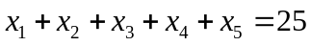 where 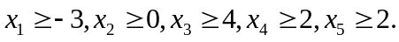 | L2 | CO4 | [5M]
 | b) | Suppose 200 faculty members can speak French, 50 can speak Russian, 100 can speak Spanish, 20 can speak both French and Russian, 60 can speak both French and Spanish, 35 can speak both Russian and Spanish. But only 10 can speak French, Russian and Spanish. Use suitable principle to find how many speak either French or Russian or Spanish. | L2 | CO4 | [5M]
15. | a) | Utilize method of characteristic roots to solve the recurrence relation 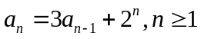 and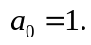 | L3 | CO5 | [5M]
 | b) | Make use of generating functions to solve the recurrence relation 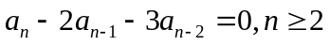with 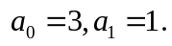 | L3 | CO5 | [5M]
16. | a) | Make use of BFS algorithm to find a spanning tree of the following graph  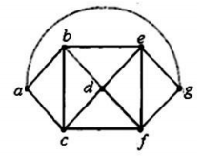 | L3 | CO6 | [5M]
 | b) | Define chromatic number of the graph. Write the chromatic number of complete graph, cycle graph, wheel graph, bipartite graph and regular graph. | L2 | CO6 | [5M]
17. | a) | Show that the statement formulas 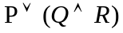 and 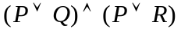 are logically equivalent. | L2 | CO1 | [4M]
 | b) | Symbolize the following argument using suitable quantifiers. “All integers are rational numbers. Some integers are powers of 2. Therefore, some rational numbers are powers of 2.” | L2 | CO2 | [3M]
 | c) | Let 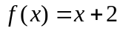 , 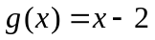 and 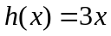 for 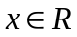 , where R is a set of real numbers. Find 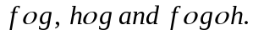 | L2 | CO3 | [3M]
18. | a) | How many 3 digit even numbers are formed with i. no digit is repeated ii. Repeated digits. | L2 | CO4 | [4M]
 | b) | Obtain the coefficients generated by the function 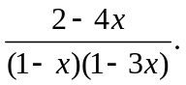 | L2 | CO5 | [3M]
 | c) | Check whether the following graph is Planner or not.  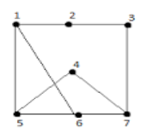 | L3 | CO6 | [3M]
-- 00 -- 00 –

